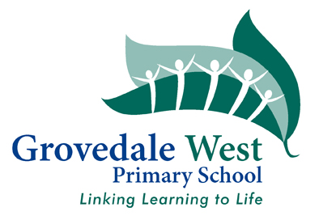

2022 Prep Transition Information
The following information will help the School to provide a smooth transition for your child. We would appreciate if you could complete any of the areas that are relevant for you. This will be read in conjunction with their Kinder Transition Statement and will assist the teacher to know more about your child.

Child’s name:
What are your child’s strengths and aspirations?
What are your child’s interests?
Pets names (if any)
Names of family members
- brothers / sisters

Does your child have a friend coming to GWPS? Please list their names.
Does your child have NDIS support - if so, who are the providers?

Does your child currently receive any private therapy? (eg: Speech, Occupational Therapy)
Is there anything else that you would like us to know about your child?
Please write on the back if required.

